

©2020-2021 PhaxTrack. This application is intended for residents of Makati City, Philippines



0949 164 2203

An Immunization Database Management System and Tracking Android Mobile Application for Makati City

phaxtrackapp@gmail.com

@PHaxtrackapp

©2020-2021 PhaxTrack. This application is intended for residents of Makati City, Philippines

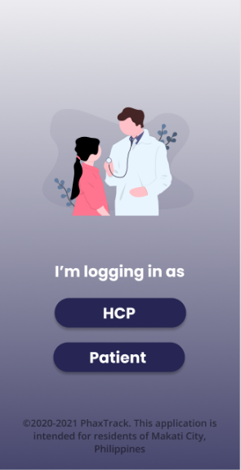

The PHax Track will manage data and it will be connected to the centralized database. Each Filipino will be given an identification number that will be used for their accounts in the database.

HOW IT WORKS?

Just simply click the button if you are a Health Care Professional or a patient and it will redirect you to the login form.

After choosing between Health Care Professional (HCP) and patient, you will redirect to the login form.

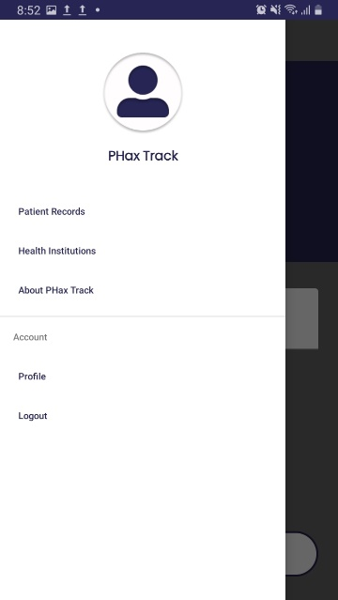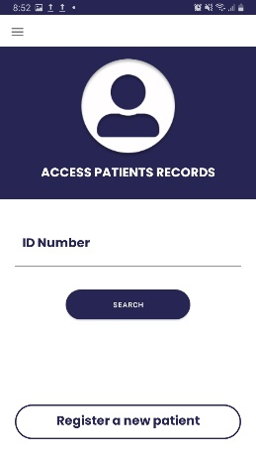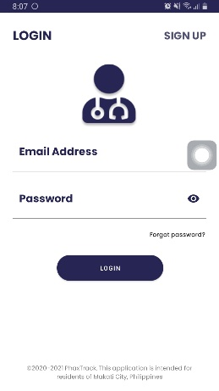

Here is the list of all navigation tab that you will see in the side bar.

Logout

Doctor’s Profile

About Phax Track

List of health institutions

Access patient records

Username

Profile picture

Sidebar bar

Click to register new patient

Once you login, you will redirect to this page. Here, you can search for patient by typing its id number. After that, the system will ask for the password of that patient. This is for the permission in accessing the confidential record of the patient.

2

Fill up the form with your email address and password and click the login button.

If you don’t have account yet, just click the sign up at the right top corner of the screen.

By clicking this you will be ask to enter your valid email address. And the password reset link will be sent to your email address.

Click to sign up

FOR HEALTH CARE PROFESSIONAL (HCP)

1

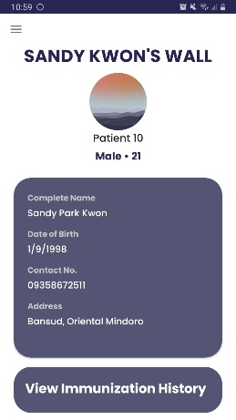

This is the Patient wall, the HCP can see all the record of the patient, as well as the vaccines being taken, and all the files and documents uploaded, the comment of the HCP and the adverse experience of the patient.

3

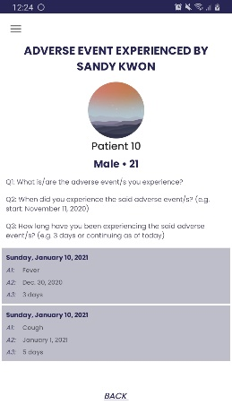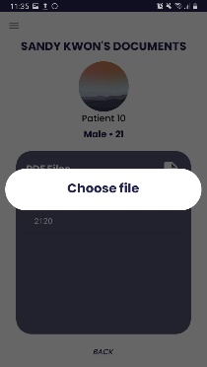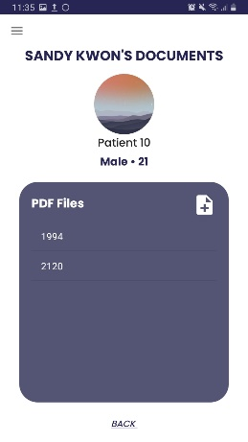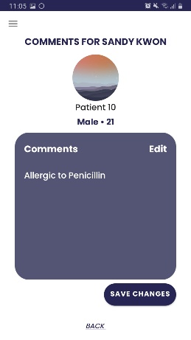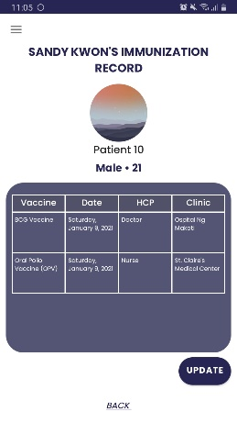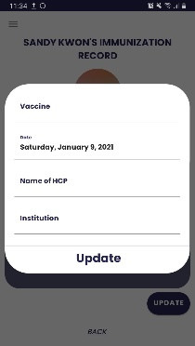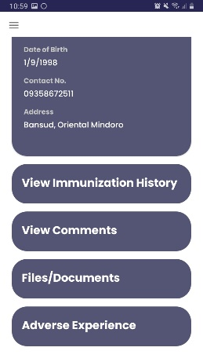

d

List of questions

List of adverse experience

Comments

List of vaccines

List of files

Click the add icon to upload files.

c

Back to patient wall

And then click to save changes.

Click edit to add, remove, or change comment.

b.

Click to update vaccine

a.

1. Adverse experience of patient
2. Files and documents uploaded
3. Comments of HCP
4. Immunization history

Scroll Up

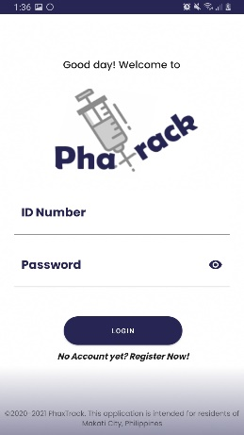

1

Fill up the form with you ID number and password.

If you don’t have account yet, you can sign up by clicking the register now. The ID number will be given after you successfully sign up.

FOR PATIENT

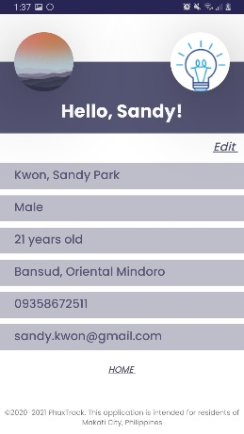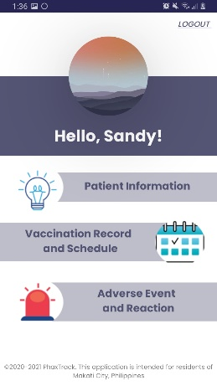

Click edit to change your information

Click home to go back to your dashboard.

Patient information

You will see your full name, gender, age, address, contact number, and email address.

a

2

1. Adverse Event and Reaction
2. Patient Information
3. Vaccination Record and Schedule

Click to logout.

After you login, you will redirect to your dashboard.

Click to login.

Click to register.

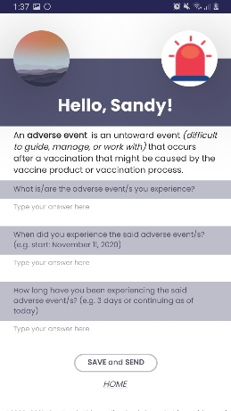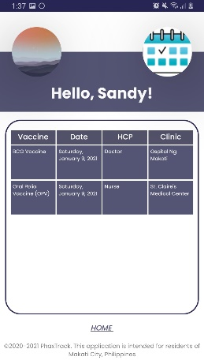

0949 164 2203

phaxtrackapp@gmail.com

CONTACT US

@PHaxtrackapp

RESEARCHER

Moses Ching Darlene Libatique

Noreen Gonda Shekaniah Solapco

©2020-2021 PhaxTrack. This application is intended for residents of Makati City, Philippines

Click save and send after you answer all the question

Adverse Event and Reaction

Answer all the question if you experience any adverse event after the vaccination. All the answer will be send to your health care provider.

c

b

Vaccination Record and Schedule

You will see all the vaccine history including the vaccine name, date, hcp and the clinic.

Click home to go back to your dashboard.